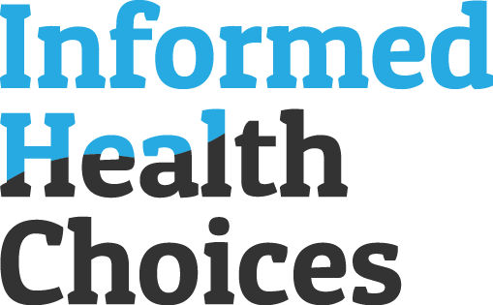

IHC Choice team
Working paper, 02. February 2020

Development of learning resources

Protocol for a context analysis:
Exploring the considerations for
introducing digital learning resources for critical thinking about health in
secondary schools

(A basis for country-specific protocols)

www.informedhealthchoices.org

Colophon
Title | Protocol for a context analysis: Exploring the considerations for  introducing digital learning resources for critical thinking about health in secondary schools
Authors | IHC CHOICE team:  Faith Chelagat^{3, 5}  Micheal Mugisha^{3, 4}  Andrew D Oxman²  Matt Oxman²  Sarah Rosenbaum²  Ronald Ssenyonga^{1,3}  1. Makerere University College of Health Sciences, Uganda, 2. Norwegian Institute of Public Health, Norway, 3. University of Oslo, Norway, 4. University of Rwanda, Rwanda, 5. Tropical Institute of Community Health and Development (TICH), Kisumu, Kenya,
Corresponding  author | Sarah Rosenbaum  saro@fhi.no
Citation | IHC Choice team. Protocol for a context analysis: Exploring the considerations for introducing digital learning resources for critical thinking about health in secondary schools. Norwegian Institute of Public Health. 2020
Article category | ☐ About Informed Health Choices  ☐ Key concepts and glossary  ☐ Learning resources  ☐ Systematic reviews  ☑ Development of learning resources  ☐ Evaluation of learning resources  ☐ Contextualising learning resources  ☐ Claim evaluation tools  ☐ Editorials and commentaries  ☐ Grant applications
Date | February 2020

Background
As part of the Informed Health Choices (IHC) project, we have developed and evaluated resources for helping primary school children learn to think critically about health claims and choices [1]. The resources cover 12 concepts from a framework for teaching critical thinking about treatments (health interventions), named the IHC Key Concept list. The resources together with teacher training were shown to be effective in a randomised trial with over 10,000 children in Uganda [1], and the children retained what they learned for at least one year [2]. In a process evaluation, we found that teachers, parents, and children valued the resources and supported expanding the project to other schools and age groups [3]. However, we also found that a critical barrier to adopting these resources is lack of time in school schedules for teaching new content. Printing costs also posed a significant barrier.

When developing new, digital resources for secondary school students in Kenya, Rwanda and Uganda, we will explore issues like these, which can impact eventual use and implementation of the new resources, in separate context analyses (market analyses) in each country . We will do this before starting to design the new resources, so we can address the issues in the design process.

First, it is important for us to understand what demand there is for learning resources for teaching critical thinking about health (IHC Key Concepts), and where teaching these skills best fit in the current curricula. We also want to identify any relevant learning resources that are already in use and explore how critical thinking about health is taught today, if at all. For instance, in a context analysis for Norwegian primary and lower-secondary school, we found that there is a demand for learning resources for teaching critical thinking about health. Further, we found that Norwegian resources should be designed primarily for science teachers, since the content was most likely to be considered a core element of that subject. However, we also found that they should include activities for Food & Health and Physical Education subjects, and facilitate collaboration across subjects [4].

Second, we need to gain a better understanding of other issues that might impact adoption, including: the availability of time to teach this content; who makes the decisions about what learning resources schools use, and what factors influence those decisions; and where teachers are likely to find new resources. For example, in the Norwegian analysis, we found that there was significant interest in teaching critical thinking, but very little classroom time available [4]. We also found that, although teachers were free to choose learning resources, they had little time to seek out and test new resources, and many used a specific online platform to find digital resources for teaching science.

Lastly, we need to know what information and communication technology (ICT) equipment and infrastructure teachers and students in secondary schools are likely to have access to, and if there are any plans for improvements. This will help us decide what type of ICT (e.g. devices, platforms, browser software, Internet connection) we will design the resources for. We will also identify opportunities and challenges for developing and implementing digital learning resources.

In addition, we need an understanding of how ICT and specific digital learning resources are actually used in teaching, especially in less well-equipped settings. We will explore how teachers and students are interacting with digital technology and with each other when using that technology; the barriers they face; and implications for resource design.

Objectives
- Explore what demand there is for learning resources for teaching critical thinking about health in secondary schools in [Kenya/Rwanda/Uganda]
- Map where teaching critical thinking about health best fits in the curriculum
- Identify and examine relevant resources already in use
- Explore conditions for introducing new learning resources
- Describe what ICT (e.g. devices, platforms, browser software, Internet connection) is likely to be accessible in [Kenyan/Rwandan/Ugandan] secondary schools for teaching and learning purposes, and what, if any, national plans there are for improvements
- Explore how digital learning resources are used in teaching, particularly in less well-equipped settings (how teachers and students interact with the technology/eachother; what barriers they face and work-arounds they use; implications for designing resources)
- Identify opportunities and challenges for developing digital learning resources

Methods

Approach
We will use a qualitative descriptive approach [5]. This entails creating a straightforward description of phenomena and requires less interpretation than in an “interpretive descriptive” approach, meaning that the researcher does not move far from or into the data. The sampling is purposive and the output is a coherent descriptive summary - in this case, a description that will inform the development of secondary school resources and, assuming they are found effective, plans for scaling up their use.

We will collect data by: 1) undertaking document analyses, and 2) conducting semi-structured interviews with teachers, head teachers, curriculum developers and policymakers. The document analysis will help inform who we interview and what we ask participants, while the interviews will help inform what existing resources or other documents we examine and what we look for in these.

Document analysis

Curriculum
We will review the national curriculum for secondary school students, and map relevant parts of the curriculum against the IHC Key Concepts. We will acquire the documents by consulting curriculum developers, teachers or head teachers, or through Internet searches. At least one science teacher or curriculum developer will be asked to examine the mapping and identify links to the curriculum we may have missed. A similar exercise has been carried out in the United Kingdom for Key Stage 3 of the National Science Curriculum [6]. See Appendix 5 for notes on how this was carried out.

Existing learning resources
We will ask curriculum developers, teachers and head teachers to identify commonly used textbooks and digital learning resources for teaching science and health. We look at resources for these broader topics in order to examine to what extent to which these resources cover learning to think critically about health.

ICT in secondary schools
If available, we will review documents that describe country-level status of ICT for teaching purposes in secondary schools (as oppsed to for administrative purposes). We will identify these documents by contacting the Ministry of education, national office of statistics, other key stakeholders, or through Internet searches. We will not collect new data, but search for existing data from, for example, reports or policy documents that can provide information relevant for resource development. For a list of the type of questions we are focusing on, see interview guide Topic 3.

Semi-structured interviews

Purposive sampling
Stakeholders whom we will interview include: policymakers, such as curriculum developers; people responsible for ICT in secondary schools at a national level; and secondary school teachers and head teachers (and their ICT managers if necessary). Participants may include people in our advisory group or teachers network in [country] (see protocol for stakeholder engagement).

The aforementioned context analysis for Norwegian primary and lower secondary school suggested science is the most relevant subject for teaching critical thinking about health, so we will include science teachers in the context analysis in [Kenya/Rwanda/Uganda]. However, if it becomes apparent that the content might also fit in other subjects, we will seek out teachers of those subjects. We will interview teachers, head teachers and ICT managers from different types of schools (large/small, rural/urban, well-equipped/less well-equipped). We will consider interviewing publishers or developers of learning resources in each country, if it is feasible and if it seems likely to provide valuable information. Finally, we will ask participants to suggest other people we should interview. See the protocol for stakeholder engagement for more information about recruiting participants.

Data collection
We will use a semi-structured interview guide (Appendix 1) that includes questions about the participant and, if applicable, their school, and questions related to the objectives for the context analysis. We will use the same interview guide for all stakeholders, but in a given interview focus on the questions that are most relevant to the informant. The initial interview guide will be piloted with two participants and modified. As data is collected, the interview guide will be further modified to exclude questions that are already covered satisfactorily, and add or alter questions that need more exploration.

The number of interviews will be determined pragmatically, rather than be predetermined. We expect to find important differences in data collected from teachers, head teachers and ICT managers across rural and urban, and public and private schools. We will aim for data saturation in terms of those differences, as far as time allows .

Participants will be encouraged to speak freely and allowed to lead the interview in new, relevant directions they think are important. Interviews will be conducted face-to-face, by phone or over the Internet. When possible, two researchers will participate in the interview, with one responsible for the conversation and the other taking notes. All interviews will be recorded and transcribed.

School visits
We will purposively sample a small number of schools from both rural and urban/semi-urban areas, private and public schools, and that we have reason to expect much or little access to ICT technology for teaching and learning. We will observe lessons where teachers and students are using ICT technology. We will interview ICT managers, teachers who use ICT in their teaching, students who particpate in classes where ICT is used for teaching and learning.

Data analysis
Two researchers will code findings from each interview immediately after the interview is conducted, so that findings can inform interview guide modifications before the next interviews.

We will combine data collected from the document analysis and from interviews, and analyse the pooled data using a framework approach for applied research [7]. Framework analyses differ from other thematic analyses in that they are part deductive, with pre-set objectives [8]. Reflecting our objectives, the initial themes are:

- Demand for learning resources to teach critical thinking about health
- Curricula links to critical thinking about health (IHC Key Concepts) (current and expected)

- Current learning resources used to teach critical thinking, health, and critical thinking about health
- Opportunities and challenges for teaching critical thinking about health
- Current and expected ICT conditions for teaching/learning purposes in secondary schools
- Opportunities and challenges for developing digital learning resources
- Current digital learning resources (good and bad examples)

Ethical considerations
Informed consent
Participation will be voluntary. We will provide participants with information based on guidance from the Norwegian National Research Ethics Committee, including information about the aim of the project, why we are requesting their participation, the voluntary nature of their consent, how we will collect the data and what will happen to it, and who they can contact for questions. We will collect written consent to participation in interviews (Appendix 2). We will collect separate consent to record interviews, using the same form—i.e. participants will have the option of participating without being recorded. Recordings will be stored securely until transcripts are complete, and then be erased. Transcripts will be made anonymous.
We will also for permission and collect written consent from any people who we take photos or videos of during school visits or interviews. If those people are under 18, we will additionally collect written consent from a parent or, when this is not feasible, from their head teacher. (Appendix 3).

Institutional ethics and data privacy protection assessments
The lead partner is the Norwegian Institute of Public Health. The Regional Committee for Medical Research Ethics (REC) has the authority for approving or disapproving medical research studies conducted within Norway, or by Norwegian institutions, in accordance with ACT 2009-06-20 no. 44: Act on medical and health research (the Health Research Act).
EU Data-protection considerations

Personal data is any information that relates to an identified or identifiable living individual. This includes names, addresses, email addresses, phone numbers, IP addresses, identifiers that can be retraced, etc.

We will store personal data (such as names and contact information) with freely given informed consent from the participant.

We will not store this information longer than necessary. It will not be stored together with transcripts, which will be de-identified. When the study is completed, personal data will be deleted. See other key rules for processing personal data.

We are not collecting any sensitive data, such as information about racial or ethnic origin, political opinions, health-related data, etc.

This study does not include data collection from children.

We will otherwise following standard guidance for research ethics, including protection of individual’s privacy, such as ensuring that transcripts and published results are anonymised.

In response to our application, REC has concluded that this study falls outside of its remit, because it is not medical or health research aiming to generate new knowledge about health and diseases. Therefore it does not require submission for REC approval. They stated further that it is up to the Norwegian Institute of Public Health to oversee that the project is carried out responsibly, for instance with regards to data privacy protection and informed consent. (See Appendix 4).

The Norwegian Institute of Public Health has a set of routines to ensure that any data collection, handling and storage adheres to the General Data Protection Regulation in Norway/EU. A full assessment form for the development phase of the project was submitted to the Data Protection Officer, and approved in January 2020. The pre-assessment was approved, and it was determined that a full data protection impact assessment was not necessary for this project.

Each partner country needs to follow ethical requirements for their setting, including any formal approvals necessary.

Results and Discussion

References
- Nsangi A, Semakula D, Oxman AD, Austvoll-Dahlgren A, Oxman M, Rosenbaum S, et al. Effects of the Informed Health Choices primary school intervention on the ability of children in Uganda to assess the reliability of claims about treatment effects: a cluster-randomised controlled trial. Lancet 2017; 390:374–88.
- Nsangi A, Semakula D, Oxman AD, Austvoll-Dahlgren A, Oxman M, Rosenbaum S, et al. Effects of the Informed Health Choices primary school intervention on the ability of children in Uganda to assess the reliability of claims about treatment effects, one-year follow-up: a cluster-randomised trial. Submitted.
- Nsangi A, Semakula D, Glenton C, Lewin S, Oxman AD, Oxman M, Rosenbaum S, Dahlgren A, Nyirazinyoye L, Kaseje M, Rose CJ, Fretheim A, Sewankambo NK. Informed health choices intervention to teach primary school children in low-income countries to assess claims about treatment effects: process evaluation. BMJ Open 2019;9:e030787. doi: 10.1136/bmjopen-2019-030787 https://bmjopen.bmj.com/content/9/9/e030787
- Lund HM, Mathisen PE, Rekkavik ME, Voll E. Teaching critical thinking about health claims: market analysis for Norwegian primary and lower secondary school. Informed Health Choices Working Paper, 2018
- Sandelowski, M. (2000) Whatever happened to qualitative description? Research in Nursing & Health, 23 (4), s. 334-340. http://citeseerx.ist.psu.edu/viewdoc/download?doi=10.1.1.461.4974&rep=rep1&type=pdf
- Chalmers I, Oxman AD, Austvoll- Dahlgren A, et al. Key Concepts for Informed Health Choices: a framework for helping people learn how to assess treatment claims and make informed choices. BMJ Evidence-Based Medicine 2018;23:29–33.
- Ritchie, J. and Spencer, L. (1994) ‘Qualitative data analysis for applied policy research’, in Analyzing qualitative data, pp. 173–194.
- Pope, C., Ziebland, S. and Mays, N. (2000) ‘Qualitative research in health care Analysing qualitative data’, Bmj, 320(January), pp. 114–116. doi: 10.1136/bmj.320.7227.114.

Appendix list
Appendix 1: Interview guide
Appendix 2: Participant information and consent form
Appendix 3: Answer from Norwegian Regional Committee for Medical Research Ethics (REC)
Appendix 4: Norwegian Institute of Public Health, Data protection pre-assessment approval

Appendix 1: Interview guide

IHC CHOICE – Context analysis interviews
Country
Interview no.:
Date:
Interviewer/Observer:
Audio recording?

BEFORE THE INTERVIEW: INTRODUCTION AND CONSENT

Introduce yourself and your role in the project, briefly.

Refer to the information that the participant should have receiveed via email beforehand.

Inform the participant about their rights and our responsibilities.
- Data will be handled anonymously.
- Sensitive personal information will not be saved.
- They are free to end the interview at any time, without giving a reason.

Describe and explain the project, briefly, using plain language.
- There are many claims about what is good for our health.
- Many of those claims are unreliable (we cannot be sure that they are correct).
- To make good choices for our health, we must be able to separate reliable from unreliable health claims.
- Many people have not learned how to do this.
- [Your university] together with partners in other countries, are developing resources for secondary schools, to help students think critically (carefully) about health choices.

Explain the purpose of the interview, briefly:
- We want to learn from your experience, so the resources we develop are appropriate.
- You are not being tested, and there are no wrong answers.

Request written consent to participation and to being recorded
Begin recording if given written consent to do so

INTERVIEW

Ask the participant to introduce themselves (without revealing their identity)
Prompts for teachers
- Subjects taught, in what grades
- Type of school
- Class sizes

Topic 1:
Teaching critical thinking, health, and critical thinking about health
Prompts
- How is critical thinking taught today?
- How is health taught today?
- How is critical thinking about health being taught today?
- What need is there for teaching critical thinking about health?
- Where in the curriculum can it fit in?
- How much time could potentially be made available to teach critical thinking about health and how/where? (What could it replace?)
- What plans are there for developing the national curriculum with respect to critical thinking, health, and critical thinking about health?
- What are challenges to teaching students critical thinking about health?

Topic 2:
Learning resources for teaching critical thinking, health and critical thinking about health
Prompts
- What resources are currently used to teach these subjects?
- Who makes decisions about which learning resources to use and how?
- Where are learning resources typically found or accessed by teachers?

Topic 3:
Information and Communication Technology (ICT)
Prompts
- What technologies are being used in secondary schools today for teaching and learning purposes? (For teachers and head teachers, answer about conditions in your school. Teachers may not have all the answers to these questions – they can refer you to their ICT manager.)

  - What type(s) of devices (e.g. computer, tablet, smartphone) and how old are they?
  - Who owns the devices (do students or teachers own a device or do they rely on what is provided at school?)

  - How many students/teachers to device?
  - What operating system(s) (e.g. Windows, OS or Linux on desktop/laptop computers; iOS, Android, Chrome OS on tablets/smartphones)? What version(s)?
  - What type/version of browsers (e.g. Safari, Chrome, Internet Explorer 9)?

- How are technologies being used today?
  - When and how much can students/teachers use devices?
  - Can they access device at home?

  - Do students use devices individually and/or in groups?
  - Do teachers interact directly with students through the technology?
  - Describe some typical ways technology is used in teaching.

- Updating, maintenance, networks, internet
  - How easy is it to update a software or a version (for instance operating systems or browsers)?
  - Who is in charge of maintenance?
  - How easy is it to contact them?
  - Is there any central storage, or would it be feasible to manage information in the cloud?
  - How are resources downloaded?
  - How is information uploaded (for instance student’s homework or answers to tests)?
  - How are learning resources distributed to students? (e.g. downloaded directly, or downloaded to a local network and distributed from there)
  - Quality, availability of the internet connection

  - Firewalls / security systems

- What are the main challenges using ICT in teaching (e.g. maintenance, connectivity, power supply, support, computers per student, etc), and what are the work-arounds to these issues?
- What plans are there for introducing or improving technologies in the future?
- How does your school compare with other schools that you are familiar with (regarding ICT)?
Topic 4:
Opportunities and challenges for using digital resources
Prompts
- Examples of good and bad digital resources used today
- What opportunities are there for using digital learning resources?
- What challenges are there to using digital learning resources?
- Are there any standards or guidelines for developers of digital learning resources for [Kenyan/Rwandan/Ugandan] schools?

Other people we should talk to
- Do you have suggestions of people we should talk to?
- If yes, do you give your consent for us to identify you as the person who recommended we contact them?

Other comments
- Is there anything you want to add?

Thank the participant for their time and insight.

Appendix 2: Participant information and consent form

PARTICIPANT INFORMATION SHEET TEMPLATE FOR ADULTS
[Place your logo here]

invitation to participate in a research project

Enabling sustainable public engagement in improving health and health equity
You are invited to participate in a research project. The aim of this project is to develop and evaluate digital learning resources for enabling secondary school students to think carefully about health choices. [Insert information regarding why the person has been selected for possible participation, and information about how the project manager or institution has identified the person.]

What IS THE Project ABOUT?
In the first phase of the project we need to learn more from people like you who teach science (or other relevant subjects) in secondary schools, and who use digital learning resources. Your interview will last approximately 1 hour. With your permission, we would like to audio-record the interview. After transcribing, the recording will be deleted. The transcript will not contain your name or other information that can directly identify you.

FORESEEABLE BENEFITS AND PREDICTABLE RISKS AND BURDENS OF TAKING PART
There are no foreseeable risks or burdens in taking part, other than the loss of time you are spending talking to us. Foreseeable benefits may include increased knowledge about our area of research: thinking carefully about health claims and choices. Another possible benefit is ensuring the final learning resources, which you may use, satisfy your needs and preferences.

Voluntary participation and the possibIlity to withdraw consent
Participation in the project is voluntary. If you wish to take part, you will need to sign the declaration of consent on the last page.
You can, at any given time and without reason withdraw your consent or withdraw from the project. This will not have any consequences for you. If you at a later point, wish to withdraw consent or have questions regarding the project, you can contact us. See contact information below.
You have the right to access information that has been recorded about you and the right to stipulate that any error(s) in the information that is recorded is/are corrected. All information will be processed and used without your name or personal identification number, or any other information that

is directly identifiable to you. A code links you and your personal data concerning health via an identifier list. Only [insert the name of the project manager, and possibly others that are involved in the project] will have access to this list.
Information about you will be anonymised or deleted five years after the project has ended.

Approval
[Insert relevant institution name] has reviewed and approved this Research Project [insert reference/year].

contact information
If you have any questions regarding the research project, you can get in touch with [insert name, telephone number and email address of the project manager, and another permanent member of the project].

I consent to participating in the research project

City/Town and date | Participant’s Signature
 | Participant’s Name (in BLOCK LETTERS)

For the researcher:
I confirm that I have given information about the research project [You can include this sentence if you wish, only in the instances where the information is given face to face.]

Place and date | Signature
 | Role in the research project

Appendix 3: Photo and video consent form

Consent to the use of video and photos for the Informed Health Choices project

What is the Informed Health Choices project? The goal of the project is to help people make better health choices, so they suffer less and avoid wasting money. We try to achieve our goal by developing free learning resources, such as books and games.

Why do we want to use the video and/or photos? We use video and photos to help people learn about the project and the learning resources.
Where will they be used? Videos and photos may be used: in the learning resources; on the project website; in presentations at meetings and conferences; in scientific journals; in the news media; and in social media, such as Twitter and Facebook.
If you sign the form, what does that mean? If you sign the form on the next page, you give us permission to use the video and/or photos of you, or the child for whom you are responsible.

Will anyone be paid? No. Neither we nor you will get money for use of the videos or photos.

Where can you get more information? If you have questions or concerns, you can; call or email the contact person/project representative listed below; email contact@informedhealthchoices.org; or visit our website, www.informedhealthchoices.org.

To be completed by the contact person/project representative:

Name:

Organisation:

Address:

Phone number:

Email address:

Name of the person in the video or photos:

If that person is a child, name of the consenting adult and their relation to the child:

(see page 2 of 2)

To be completed by the person in the video and/or photos.

If the person is a child, to be completed by the consenting adult together with the child.

By filling in and signing this form, I consent to the video and/or photos being used by the Informed Health Choices project, to help people learn about the project.

I understand that:
- No names will be published with the video and/or photos, but it is possible that somebody, for example a family member, will recognise persons in the video and/or photos.
- The videos and/or photos may be shared: in the learning resources; on the project website; in presentations at meetings and conferences; in scientific journals; in the news media; and in social media, such as Twitter and Facebook.
- I will not receive money for use of the videos and/or photos.
- I can revoke (take back) my permission to use the video and/or photos, but this will only apply to future use, meaning the videos and/or photos will not be removed where they have already been used.
- This form will be kept securely by the project, but it may be shared with others who wish to use the videos or photos, for example scientific journals.

Name of person in the video or photos:

Signature:

Date:

If the person is a child:
Name of consenting adult and relation to the child:

Signature:

Date:

Name of witness:

Signature:

Date:

Appendix 4: Answer from Norwegian Regional Committee for Medical Research Ethics (REC)

Translation from email in Norwegian (see image of original on next page):

Hi
Referring to your project review request "To prepare the ground for a sustainable, popular commitment to improving health and inequality in health" (our ref. 30713).
The secretariat for REK south-east D has considered the inquiry.
The purpose of the project is: "To develop and evaluate learning resources for secondary school students to help them make informed personal choices about caring for their health and to participate as scientifically literate citizens in health policy deliberations."
The Secretariat considers that the project, as presented in the application and protocol, will not provide new knowledge about health and illness. The project therefore falls outside the mandate of REK under the Health Research Act, which presupposes that the purpose of the project is to provide "new knowledge about health and illness", see section 2 and section 4 (a) of the Act.
It is the institution's responsibility to ensure that the project is carried out in a proper manner with regard to, for example, confidentiality and privacy rules and obtaining local approvals.
I would like to point out that the conclusion is to be regarded as indicative cf. Section 11 of the Public Administration Act If you still wish to apply for the REK, the application will be considered at a committee meeting, and a single decision will be made under the Public Administration Act.
With best regards,
Finn Skre Fjordholm
Advisor (REK secretariat)
[Norwegian Regional Committee for Medical Research Ethics]

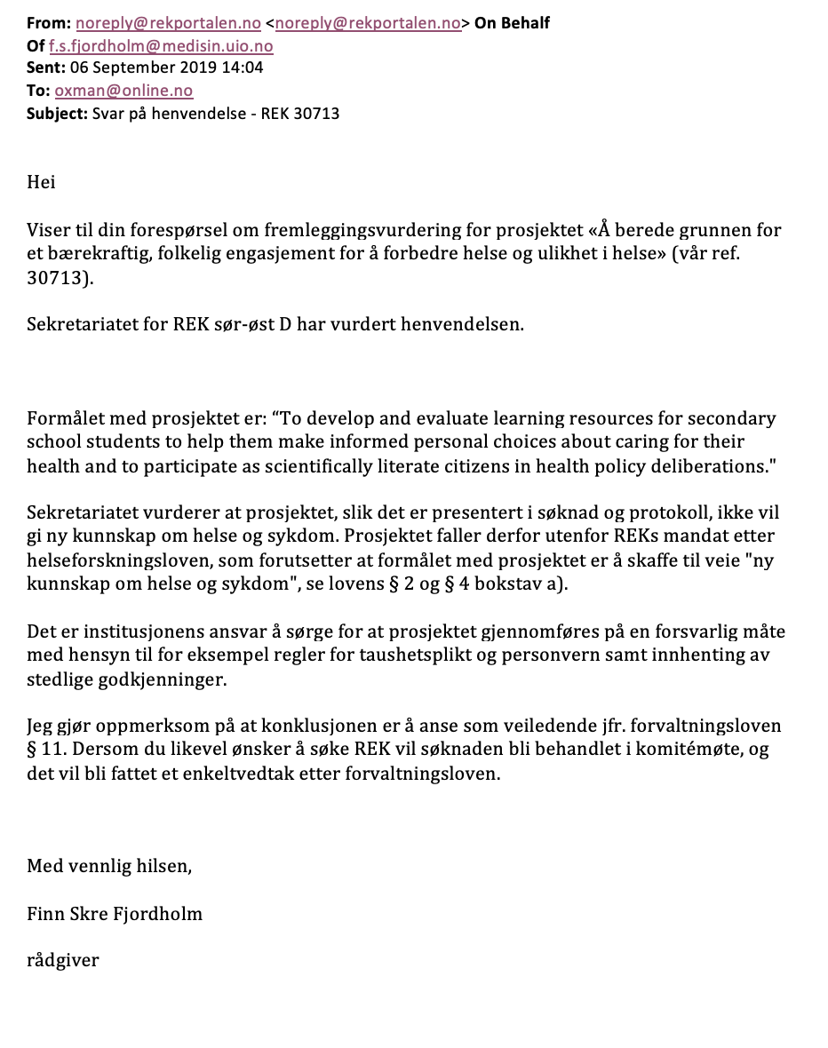

Appendix 5: Mapping curriculum to Key Concepts

Notes sent from Sarah Panell who carried out mapping of the UK curriculum to IHC Key Concepts:

“I used the National Curriculum for England https://www.gov.uk/government/publications/national-curriculum-in-england-science-programmes-of-study - this document outlines the curriculum topics that must be covered for each age group. I only looked at the curriculum for science in this instance, though there may be other links in e.g. citizenship - I am a science teacher, so I worked with the familiar curriculum statements.

I then worked through each curriculum statement and identified whether there was an explicit link to an IHC concept, copying the curriculum statement into a table accordingly. I gave each of my curriculum statements arbitrary numbers, allowing the table to be sorted either by curriculum order or by key concept. I think I could have done this more elegantly, but it was a system that worked at the time.

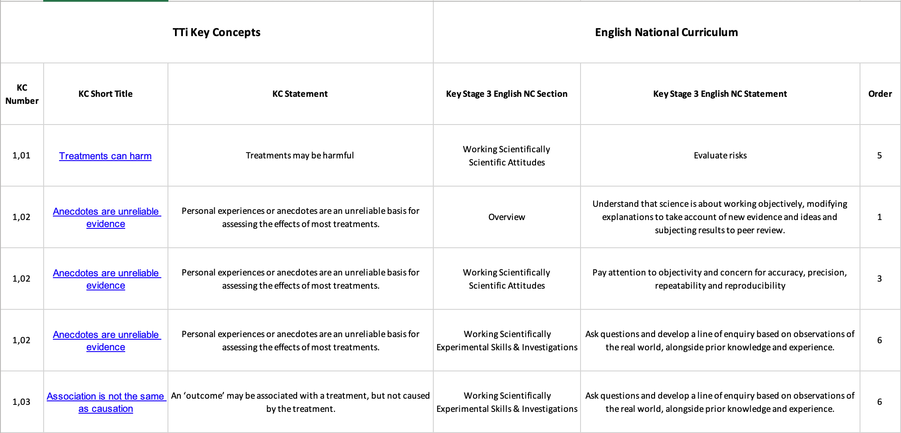

Example of how the UK curriculum mapping was organised. Complete excel file available: https://www.dropbox.com/s/iy1q5bm9tnwvwjv/National-Curriculum-KS3-vs-Key-Concepts-Spreadsheet.xlsx?dl=0 Be aware that the Key Concepts in this document are no longer the current version.

Our national curriculum is broken down into two areas: skills and knowledge. My mapping showed that the IHC key concepts were much more applicable to the statements about the skills students should be developing - perhaps this is not surprising, as the key concepts are so widely applicable to different fields. If I was to teach them in school, I would plan to embed them in a lesson that is developing knowledge but use the concepts to highlight a particular evaluative or analytical skill. One example would be in teaching about the effect of smoking on the lungs - there would be plenty of opportunities to discuss e.g. KC 1.6 as well as others.

Once I had completed my pass through the mapping, I asked two other science teachers to examine the work and identify any other links that I might have missed. Andy and Ian Chalmers also looked through it and made suggestions.

If there isn't an explicit skills section in a curriculum document, it would be harder to do this mapping - the person mapping would have to identify the expected areas of skills development within the topics.”

